**North South University**

**Department of Electrical & Computer Engineering**

**Junior Project Proposal**

**Title of the Project:**

# Smart Health Care Monitoring System Based on IoT

**Group:**

**Names and IDs of the students:**

**Name: ID:**

Ibrahim Khalil1520775042

Mashruf Mahabub 1510501042

Mostafijur Rahman 1611633042

**Faculty’s Name:** Intisar Tahmid Naheen

**Content:**

**Topic Page Number**

1. **Abstract 3**
2. **Introduction and background 3**
3. **Objectives 4**
4. **Scope 4**
5. **Methodology And Approach 4**
6. **Block Diagram 5**
7. **Software Used 5**
8. **Budget 6**
9. **Time Plan 7**

**10. Grantt Chart 7**

**11. Outcomes 8**

**12. References 8**

# Abstract:

The paper presents the design and implementation of an IOT-based health monitoring system for emergency medical services which can demonstrate collection, integration, and interoperation of IoT data flexibly which can provide support to emergency medical services like Intensive Care Units(ICU), using a Ardiuno UNO R3. The proposed model enables users to improve health related risks and reduce healthcare costs by collecting, recording, analyzing and sharing large data streams in real time and efficiently. The idea of this project came so to reduce the headache of patient to visit to doctor every time he need to check his blood pressure, heart beat rate, temperature etc. With the help of this proposal the time of both patients and doctors are saved and doctors can also help in emergency scenario as much as possible.

Keywords: Internet of thing (IoT); Medical Services; Health care; Health Monitoring;

Introduction and Background:

This project is significant in various ways because in today's world, everyday many lives are affected because the patients are not timely and properly operated. Also for real time parameter values are not efficiently measured in clinic as well as in hospitals. Sometimes it becomes difficult for hospitals to frequently check patient’s conditions. Also continuous monitoring of ICU patients is very difficult. To deal with these types of situations, our system is beneficial. Our system is designed to be used in hospitals and homes also for measuring and monitoring various parameters like temperature, ECG, heart rate, blood pressure. The results can be recorded using Arduino. Also the doctors can see those results on android app. The system will also generate an alert notification which will be sent to doctor. Our system is useful for monitoring health system of every person through easily attach the device and record it. In which we can analysis patient’s condition through their past data, we will recommend medicines if any emergency occurred through symbolic A.I.

# Objectives:

The objectives of this project/thesis are to…..

1. Operate the patients timely and properly.

2. Efficiently measure the parameter value in clinics as well as in hospitals.

3. Enable individual to improve health related risks and reduce healthcare costs.

4. Measure and monitor various parameters like temperature, ECG, heart rate, blood pressure.

Etc.

# Scope:

Following tasks will be undertaken as a part of the proposed research-

Task 1- This project mainly finds it use in the field of medical diagnosis, in a country like Bangladesh where rural population and remote areas play an important role.

Task 2- It is important to have an effective and on-time diagnosis system. We can make the whole diagnosis process better by introducing this idea.

Task 3- We can also add many other devices like ECG sensor etc.

The main idea of the proposed system is to provide better and efficient health services to the patients by implementing a networked information cloud so that the experts and doctors could make use of this data and provide a fast and an efficient solution. The final model will be well equipped with the features where doctor can examine his patient from anywhere and anytime. Emergency scenario to send an emergency mail or message to the doctor with patient’s current status and full medical information can also be worked on.

.

# Methodology and Approach:

What is your research problem? What are the barriers in the path? How do you plan to solve those problems?

= we have to use internet all the time

What are the constraints (if any)?

=Funding is the constrains

What are the technical challenges and uncertainties?

=We have to use internet all the time to remain connected with android device

What are the different approaches to this problem?

=we will try to make an offline server to solve the problem

What is your preferred approach and why?

= We will try to create an offline server because it is the only possible way to store data without internet.

Use block diagrams, flow charts and/or tables to illustrate your system or design approach.

Block Diagram

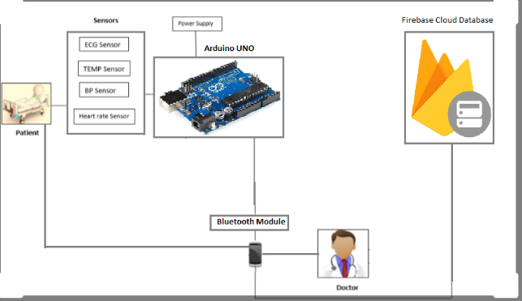

# 

# Software Used:

1, Android Studio,

2. Arduino IDE,

3. Google Firebase.

# Budget:

The total estimated budget to complete the thesis/project is provided in Table 2.

|  |  |
| --- | --- |
| **Item** | **Cost** |
| Arduino Uno | BDT 400 |
| HC-05 bluetooth module | BDT 250 |
| LM35 temperature sensor | BDT 100 |
| Humidity sensor | BDT 350 |
| Pulse rate sensor | BDT 600 |
| Push button | BDT 5 |
| 10k Resistor | BDT 5 |
| Male-female wires | BDT 50 |
| Jumper wires | BDT 50 |
| Breadboard | BDT 85 |
| LED | BDT 5 |
| **Total** | **BDT 1900** |

**Table 2:** Budget for the project/thesis

# Time-plan:

List the deliverables with specific dates so that you can make concerted effort to achieve them.

|  |  |
| --- | --- |
| Serial | Description |
| Task 1 | Arduino UNO & Arduino IDE setup and connect to the PC. |
| Task 2 | Setup the components and connect the wires. |
| Task 3 | Design an Android app. |
| Task 4 | Connect the Bluetooth module with the smartphone. |
| Task 5 | Using google Firebase make the application succeed. |
| Task 6 | Arduino IDE coding. |
| Task 7 | Check sensors one by one and collect the data. |
| Task 8 | Make a database. |
| Task 9 | Connect everything. |
| Task 10 | Finalizing and testing. |
| Task 11 | Fix bugs (if any). |

**Table 1:** List of all tasks

**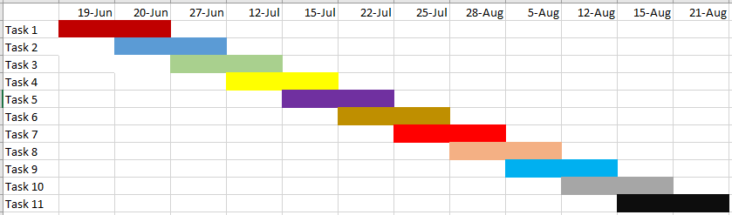**

**Figure 1:** Gantt chart

# Expected Outcomes:

1. No need to monitor from relay room.
2. Save time.
3. Save money.
4. Save men work.

References:

[1]

<https://www.arduino.cc/projects>

[2]

[https://internetofthingsagenda.techtarget.com/definition/Internet-of-Things-IoT](https://internetofthingsagenda.techtarget.com/definition/Internet-of-Things-IoT )

[3][https://cooey.co.in/](https://l.facebook.com/l.php?u=https%3A%2F%2Fcooey.co.in%2F%3Ffbclid%3DIwAR3CFwm2SvTLymbG3oxYKfdK5QgNHFhDlqJurkEHI8PmJO9o2C3KkilpFxs&h=AT2x4grSHRGWNYsEockFgvGq2qw6zagYuUZCUyd_Q7IVri2J-4CpAKVGd7smWpDFLz1cAJJ2Eh0QXlCkDQjgNidpUxRYH-0T8IQWIVZ0D152ti5p-XvrC9w_JAf8Ys5L54hX0w" \t "_blank)

[4][https://www.healthvault.com/in/en/overview](https://www.healthvault.com/in/en/overview?fbclid=IwAR2GmAL94ez7HDGKc5K7WHX_I-EEsmoskXW--e-SDbXc-thYFMq1vC4_uFg)

[5]Sharma S, Tim US, Gadia S, Wong J. “Proliferating Cloud Density through Big Data Ecosystem,

Novel XCLOUDX Classification and Emergence of as-a-Service Era”.pp.-1-20 (2015)

[6]Rintala, Mikko, Jussi Sormunen, Petri Kuisma, and Matti Rahkala. "Automation System Products and Research."(2014